Imperial vs Metric
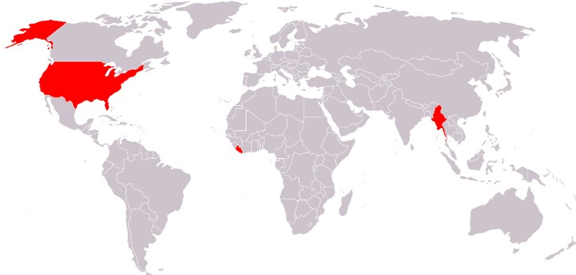
Centuries ago, the “Imperial” system of measures was used around the world. Today, most countries in the world have adopted the “Metric” system, which is based on the number “10” and makes calculations very easy. However, there are still three countries that have not officially adopted the new system: the USA, Myanmar and Liberia (see image below).


1. Weight
Imperial | Metric
ounce (oz)  pound (lb) (=16 oz)  stone (st) (=14 lb)  hundredweight (cwt) (=8 st)  ton (=20 cwt) | milligram (mg)  gram (=1000 mg)  kilogram (=1000 g)  tonne (=1000 kg)

2. Temperature
Imperial | Metric
Fahrenheit  (water freezes at 32º and  boils at 212º) | Centigrade (Celsius)  (water freezes at 0º and  boils at 100º)
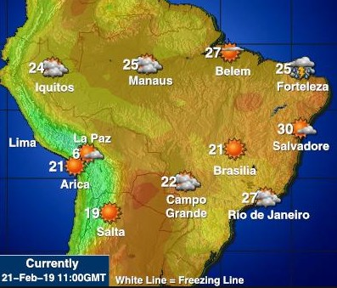
Fahrenheit remains in official use in the Bahamas, Belize, the Cayman Islands, Palau and the United States and associated territories (Puerto Rico, Guam and the U.S. Virgin Islands).
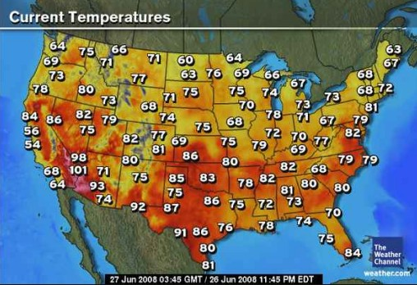

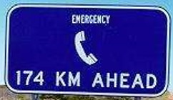
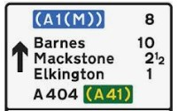
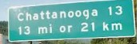
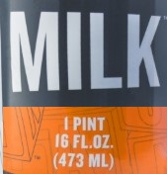
3. Volume
Imperial | Metric
fluid ounce (fl oz)  pint (pt)(=20 fl oz)  quart (qt)(=2pt)  gallon (=8pt)  bushel (used in agriculture) | milliliter (ml)  centiliter (=10 ml)  liter (=100 cl)(=1000 cm³)  cubic meter (m³) (=1000 liters)

4. Distance
Imperial | Metric
inch (in)  foot (ft)(=12 in)  yard (yd)(=3 ft)  chain (=66 ft)  furlong (=660 ft)  (= 1/8 mile)  mile (=1760 yd)  nautical mile (1’ latitude)  (=1852 m)  league (=3 n. miles) | millimeter (mm)  centimeter (=10 mm)  meter (=100 cm)  kilometer (=1000 m)

A mile is 1,760 yards, or approximately 1,609 meters. The word “mile” comes from the Latin word for “1000” (mille), because originally, it was the distance that a Roman soldier could march in 1,000 paces.
The “mile” continues to be used in Liberia, Myanmar, the USA and the UK.

5. Area
Imperial | Metric
square inch  square foot  square yard  square chain  square furlong  acre (=1 chain x 1 furlong)  square mile | square centimeter (cm²)  square meter (m²)  hectare (=100m x 100m)(= 10,000 m²)  square kilometer (km²) (= 100 hectares)

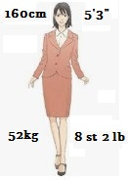
In the UK, many people still use imperial measurements:
- to order a pint of beer (=568 ml)
- to measure height in feet and inches
- to measure weight in stones and pounds
but only the metric system is taught in schools!
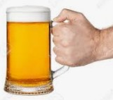

The USA tried to adopt the metric system in the 1970s, but the population refused to adopt the program, so the plan was abandoned.

The USA doesn't use true imperial measurements. It uses American Customary Units, which are a little different:
- a US pint is 16 fl oz, while an imperial pint is 20 fl oz
- a US gallon is 8 US pints (128 fl oz), while an imperial gallon is 8 imperial pints (160 fl oz)
- a US ton is 2000 lbs, while an imperial ton is 2240 lbs (a metric tonne is about 2205 lbs)

However, the USA uses the metric system for:
- Money (10 cents in a dime, 10 dimes in a dollar)
- Photography (all lenses are measured in mm)
- Medicine (drugs are measured in cc)
- Illegal drugs (cocaine is measured in grams and kg)
- Nutrition labels (grams of fat, sodium, etc.)
- Soda (Coca-Cola is sold in liter bottles – 1L, 2L, 3L, etc.)
- Car engines (cylinder volume is measured in liters – 1.0L, 1.6L, 3.0L, etc.)

The principal uses for imperial measurements in the USA are:
- Cooking measurements (measured in dozens, cups, ounces, pints, pounds, etc.)
- Distance (measured in miles)
- Temperature (measured in Fahrenheit)

Suggested video: https://www.youtube.com/watch?v=gYa1bvFO0uk (13 mins)

Conversions:
- 1 kg = 2.2 lbs
- 1 oz = 28.3 g
- Fº = Cº x 1.8 + 32
- 1 gallon = 4.55 liters
- 1 pt = 568 ml
- 1 fl oz = 29.57 ml
- 1 mile = 1.61 km
- 1 m = 1.09 yd
- 1 ft = 30.48 cm
- 1 in = 2.54 cm
- 1 acre = 4,047 m²

